**Design & Technology**

**

**Biodegradable polymers**

**Materials required for questions**

* Pencil
* Rubber
* Calculator

**Instructions**

* Use black ink or ball-point pen
* Try answer all questions
* Use the space provided to answer questions
* Calculators can be used if necessary
* For the multiple choice questions, circle your answer

**Advice**

* Marks for each question are in brackets
* Read each question fully
* Try to answer every question
* Don’t spend too much time on one question

**Good luck!**

**Q1.** Which biodegradable polymer is ideal for loose-fill packaging (e.g., foam peanuts) due to its mouldability and compostability?

**A** Corn starch polymers

**B** Biopol

**C** PHA

**Q2.** What is the primary role of Biopol (bio-batch additive) in conventional plastics?

**A** To increase flexibility

**B** To accelerate biodegradation in landfills

**C** To enhance colour retention

**Q3.** Potatopak is often used for disposable food containers because it is made from:

**A** Potato starch

**B** Petroleum by-products

**C** Recycled plastic

**Q4.** Which biodegradable polymer is produced by microorganisms and degrades naturally in soil?

**A** PHA

**B** PLA

**C** Biopol

**Q5.** Explain why bio-batch may be added to a polymer used in the manufacture of single-use carrier bags **(2 marks)**

**Q6.** Evaluate the suitability of the lactide used to manufacture the dishwasher detergent packaging shown **(4 marks)**

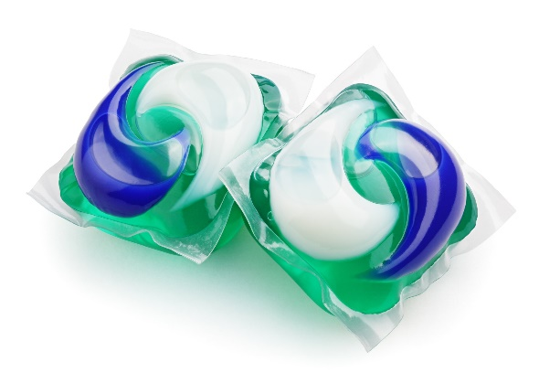

**Q7.** Explain why ‘potatopak’ is a suitable material for the manufacture of disposable cutlery **(3 marks)**

**Answers**

**Q1**. A

**Q2**. B

**Q3**. A

**Q4**. A

**Q5**.

* Carrier bags are single-use products so a bio-batch additive will help accelerate the breakdown of the carrier bag after it has been disposed of.
* Carrier bags generally have an oxy-degradable additive where the breakdown will begin with exposure to oxygen limiting their contribution to landfill.
* The inclusion of a bio-batch additive means that the carrier bag can decompose in between 3 and 6 months leaving no toxic residue or plastic particles.

**Q6.**

* Lactide is a water-soluble biopolymer which quickly breaks down when exposed to the water in the dishwasher but is not broken down by the detergent stored inside.
* As the capsule is biodegradable there is no waste packaging produced or negative environmental impact.
* Lactide can break down prematurely if picked out of the bulk packaging with damp hands, resulting in the detergent capsule leaking.
* If the capsule becomes compressed during transportation, damage could occur resulting in the detergent capsule leaking.

**Q7.**

* ‘Potatopak’ can be easily formed into the shape of cutlery using a heated compression mould
* ‘Potatopak’ is a bio-polymer that will naturally decompose when disposed of
* ‘Potatopak’ is a starch based material that is food safe
* Disposable cutlery is a single use product and wont contribute to landfill waste when disposed of.
* The use of ‘Potatopak’ reduces the demand for oil based polymers